■Product Information
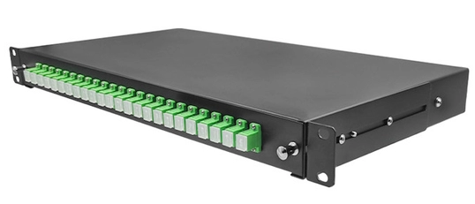
Product Name：19 Inch ODF
Product Model：24C-SC-1U- Type
■Applications
▶Optical Access Network
▶Data Processing Centers
▶Cable television
▶Local Area Network
▶Coarse Wavelength Division Multiplexer
■Features
▶Design of fixed panel
▶Drawing type structure, convenient construction operation
▶Fit for“19”rack.
▶Suitable for FC,SC,LC,ST,etc

■Configuration
Item |  | Specification | Remark
Size（mm） |  | 435*315*1U
Fiber core number | LC Pigtail | 48(DX)
 | SC Pigtail | 24（SX）
Cassette |  | 1*24C or 2*12C or 2*24C
Material |  | Cold-Rolled steel plate
Thickness of material（mm） |  | 1.2
Weight（KG） |  | 3.6
Color |  | Black
Color Number |  | /
Operating Temperature（℃） |  | -40～+65

■Optical Parameter
Item |  | Characteristics | Remarks
Pigtail | Fiber Type | G.657A1
 | Length of | 1.5M
 | Color | multicolour
Insertion Loss |  | ≤0.3dB
Return Loss |  | SM:APC≥60dB,UPC≥50dB
Repeatability |  | ≤0.2dB
Interchange |  | ≤0.2dB
Operation Temperature |  | -30～75℃
Relative Humidity |  | ≤85%
■Cable Route

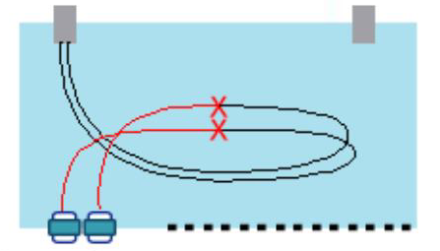

The branch cable is fused through the
molten disc in the box and the installed
cable tail fiber.

.

■Accessories
- cassette：1*24C or 2*12C or 2*24C
- Clamps：4 Set.
- fixing bolts: 4 pcs
- SC adapters: 24 pcs SC simplex
- heat shrink: 24pcs

